# Triangle - getType()

流程图

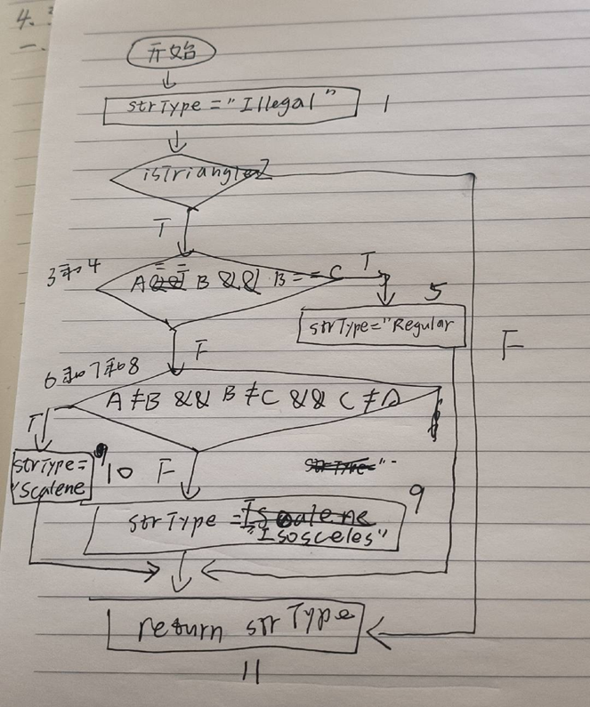

控制流图

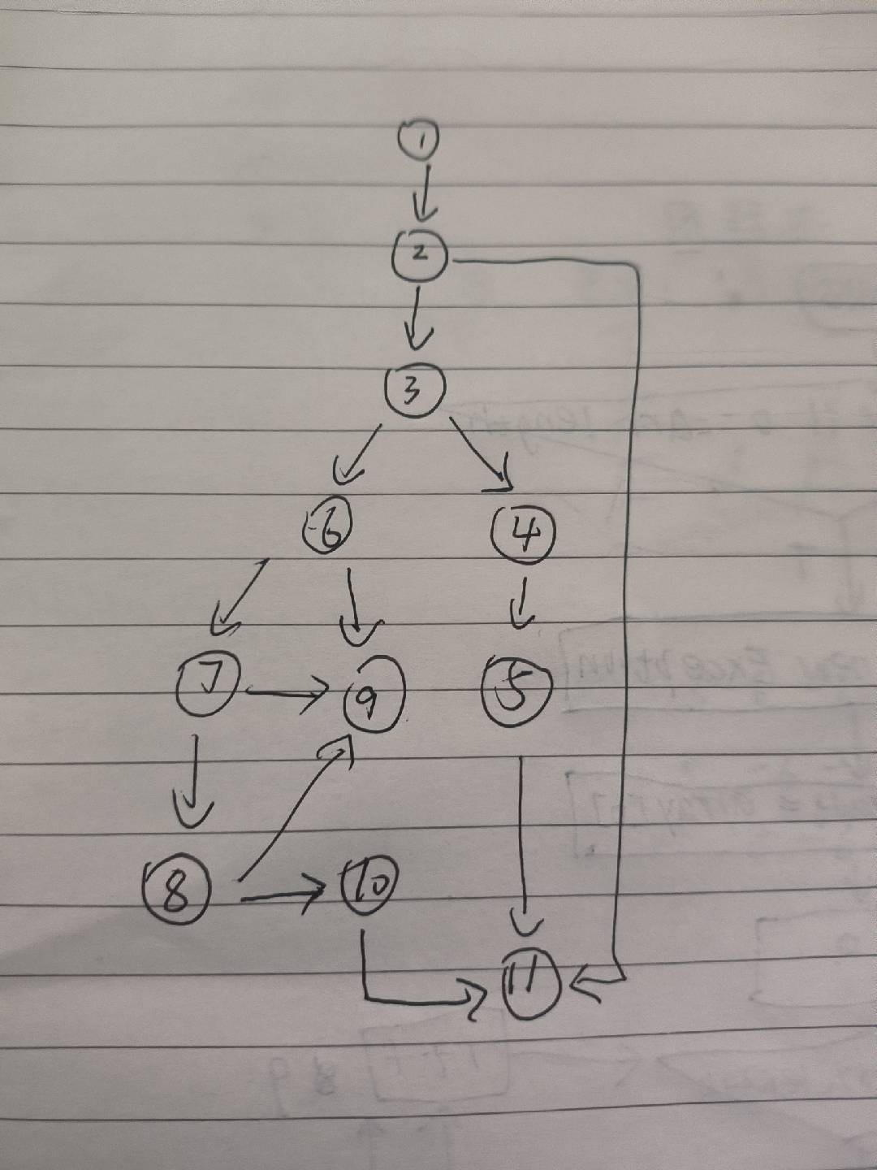

***MCDC* 覆盖**

|  |  |  |  |  |  |  |  |
| --- | --- | --- | --- | --- | --- | --- | --- |
| **⽤例** | **输⼊** | **条件 1** | | **组合条件 2** | | **组合条件3** | **结果** |
| 1 | {0,0,0} | F | | - - | | - - - | Illegal |
| 2 | {1,2,2} | T | | F - | | T F - | Isosceles |
| 3 | {2,3,2} | T | | F - | | T T F | Isosceles |
| 4 | {3,4,5} | T | | F - | | T T T | Scalene |
| 5 | {2,2,1} | T | | T F | | F - - | Isosceles |
| 6 | {2,2,2} | T | | T T | | - - - | Regular |
| **基本路径用例**  **基本路径** | | | **是否可⾏** | | **测试⽤例** | | **结果** |
| 1 2 11 | | | 可⾏ | | 1 2 3 | | Illegal |
| 1 2 3 4 5 11 | | | 可⾏ | | 2 2 2 | | Regular |
| 1 2 3 6 7 9 11 | | | 可⾏ | | 2 3 3 | | Isosceles |
| 1 2 3 6 7 8 9 11 | | | 可⾏ | | 2 3 2 | | Isosceles |
| 1 2 3 6 7 8 10 11 | | | 可⾏ | | 2 3 4 | | Scalene |
| 1 2 3 4 6 9 11 | | | 可⾏ | | 2 2 3 | | Isosceles |

1 2 3 6 9 11 不可⾏

## 编程截图

**MCDC**

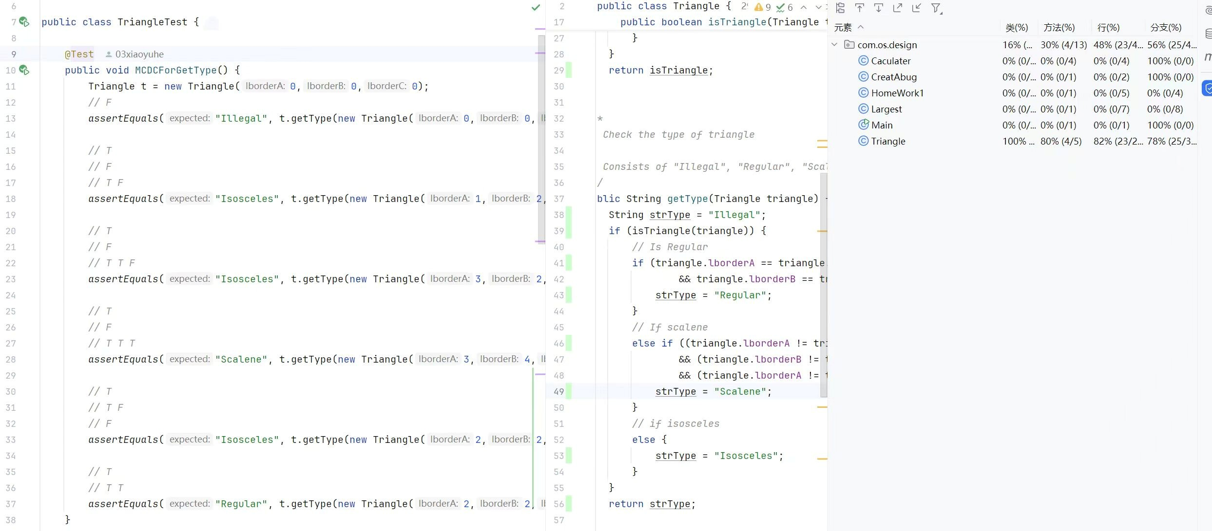

**基本路径测试**

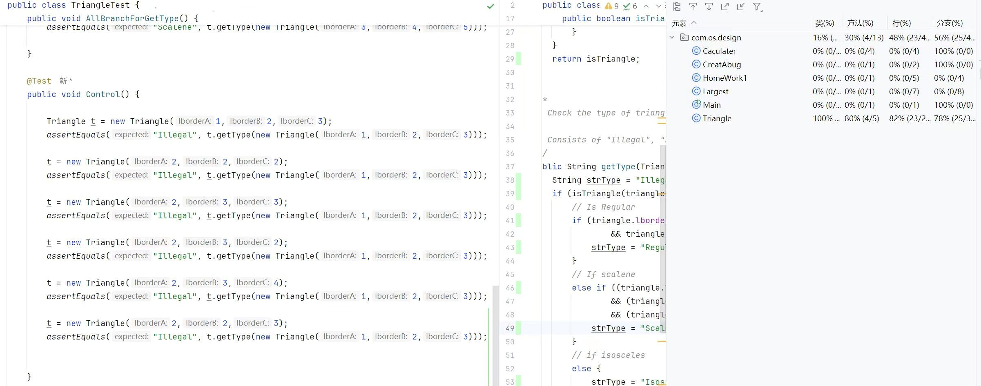

# getLargest()

## 流程图

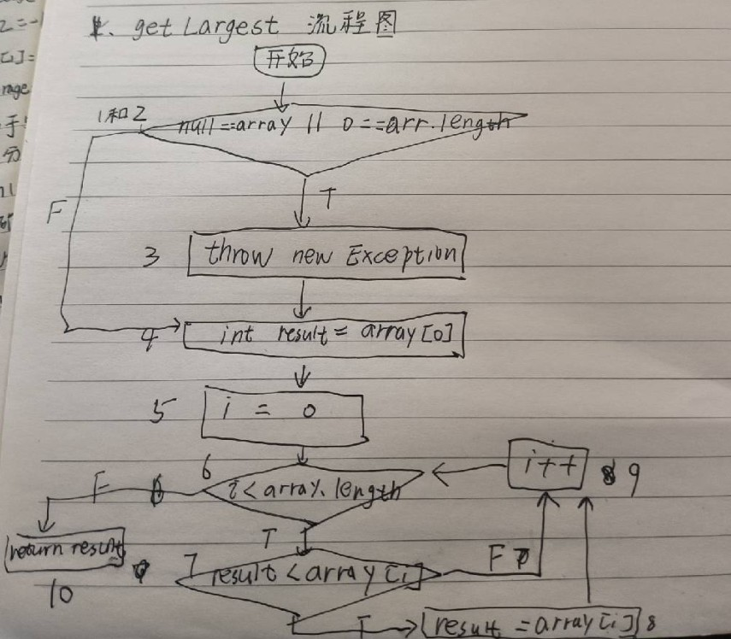

## 控制流图

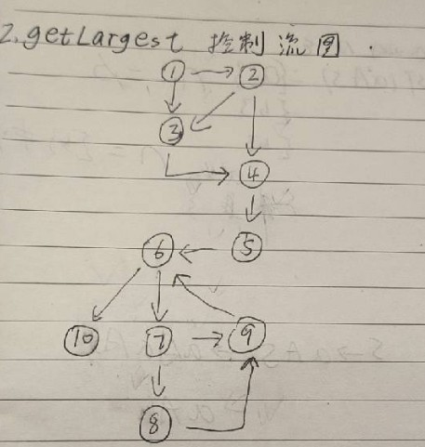

|  |  |  |  |  |  |  |
| --- | --- | --- | --- | --- | --- | --- |
|  |  | *MCDC* 覆盖 | | |  |  |
| **⽤例** | **输⼊** | **条件 1** | **条件 2** | **条件 3** | **条件 4** | **结果** |
| 1 | null | T | - | F | - | 异常 |
| 2 | [] | F | T | F | - | 异常 |
| 3 | [1,2] | F | F | T/F | T/F | 2 |

基本路径

1. **1 - 3 - 4 - 5 - 6 - 10**
2. **1 - 2 - 4 - 5 - 6 - 10**
3. **1 - 2 - 3 - 4 - 5 - 6 - 10**
4. **1 - 2 - 4 - 5 - 6 - 7 - 9 - 6 - 10**
5. **1 - 2 - 4 - 5 - 6 - 7 - 8 - 9 - 6 - 10**

## 基本路径测试⽤例

|  |  |  |
| --- | --- | --- |
| **基本路径** | **是否可⾏** | **测试⽤例** |
| (1) | 可⾏ | array = null |
| (2) | 不可⾏ | ⽆ |
| (3) | 可⾏ | array = [] |
| (4) | 可⾏ | array = [2, 1] |
| (5) | 可⾏ | array = [1, 2] |

## 编程截图

**MCDC**

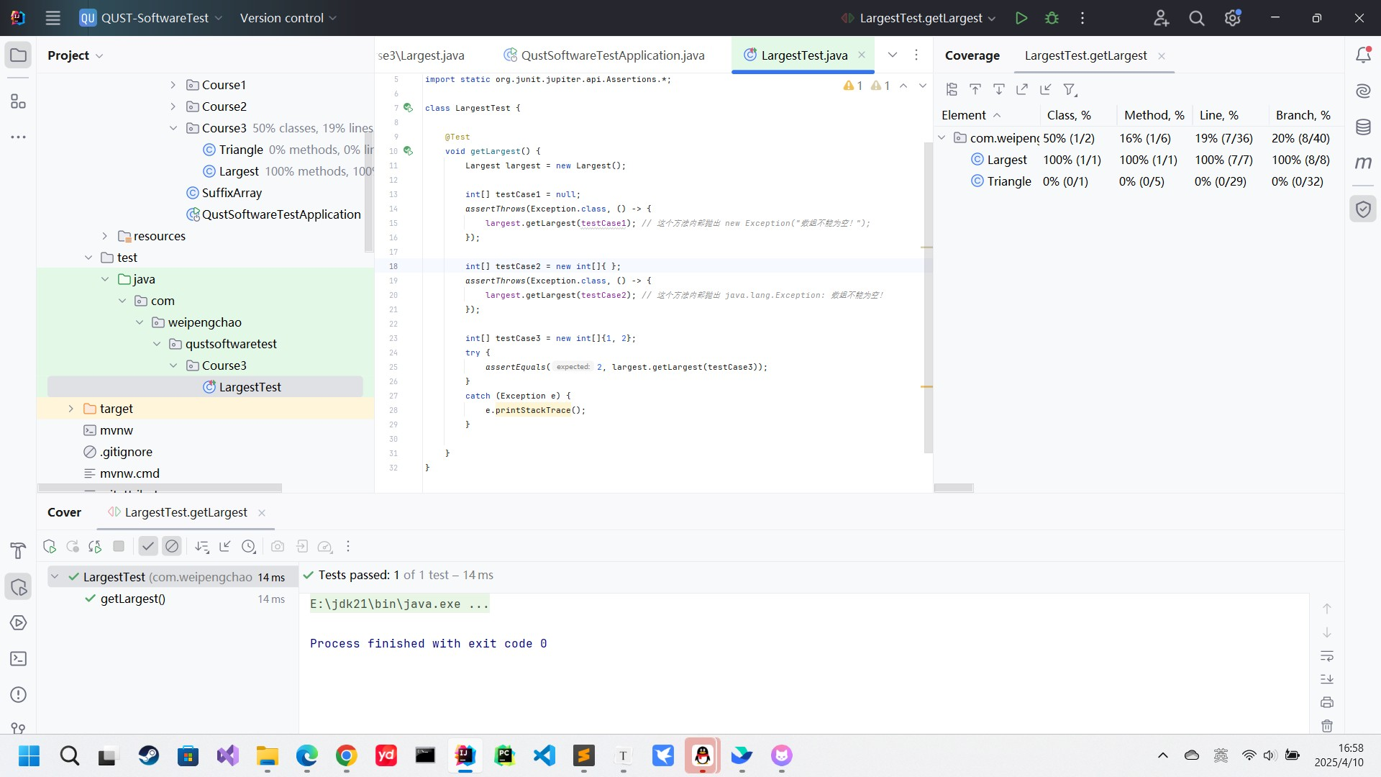

## 基本路径测试

